**Diagram Explanation:**

* **Context Diagram** (C1): Shows how the Math Booster system interacts with users (learners) and external systems like the Web Application, Mobile Application, Database, and AI Service.
* **Container Diagram** (C2): Breaks down the system into high-level containers such as the Web App, Mobile App, API, Database, and AI. Learners interact with either the Web or Mobile App to register and log in, while the API manages data flow and interacts with the Database and AI.
* **Component Diagram** (C3): Provides a deeper breakdown of the backend system's components: Authentication, User Management, Math Content Management, AI Integration, Report Generation, and MongoDB Integration.
* Code diagram (C4): This **C4 class diagram** describes the **authentication** and **user management** functionality of a system, with components for:
* **User authentication** (through AuthController, AuthService, and AuthMiddleware).
* **User profile management** (handled by UserController, UserService, and UserModel).
* **AI interactions** for recommendations or real-time responses (handled by AIController, AIService, and AIModel).
* **MongoDB schema** definitions for user data, math content, and reports (handled by MongoDBModel).

The relationships show how each class is connected and how they interact to achieve functionality like user registration, login, AI responses, and storing/retrieving data from MongoDB.

This diagram is a high-level representation of the core **business logic** and **data interactions** within the system, with each class representing an individual piece of functionality within the authentication, user management, and AI components.

**CONTEXT DIAGRAM (C1)**

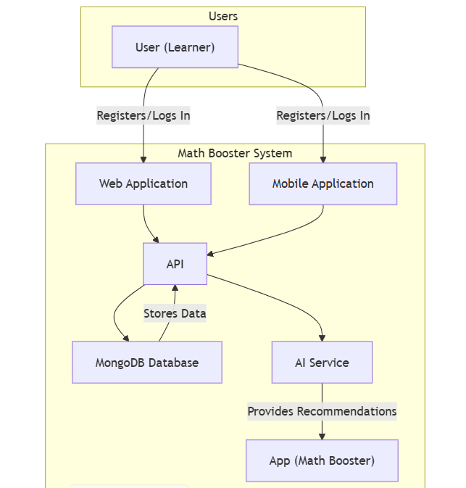

**THE CODE**

**graph** TD

**subgraph** Users

        Learner["User (Learner)"]

**end**

**subgraph** "Math Booster System"

        App["App (Math Booster)"]

        WebApp["Web Application"]

        MobileApp["Mobile Application"]

        API["API"]

        Database["MongoDB Database"]

        AI["AI Service"]

**end**

    Learner **-->**|Registers/Logs In| WebApp

    Learner **-->**|Registers/Logs In| MobileApp

    WebApp **-->** API

    MobileApp **-->** API

    API **-->** Database

    API **-->** AI

    AI **-->**|Provides Recommendations| App

    Database **-->**|Stores Data| API

**CONTAINER DIAGRAM (C2)**

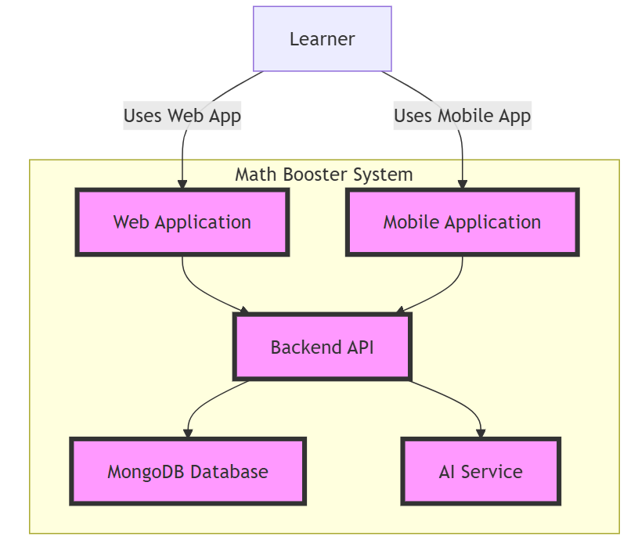

**THE CODE**

**graph** TD

**subgraph** "Math Booster System"

        direction LR

        WebApp[Web Application]

        MobileApp[Mobile Application]

        API[Backend API]

        Database[MongoDB Database]

        AI[AI Service]

**end**

    Learner **-->**|Uses Web App| WebApp

    Learner **-->**|Uses Mobile App| MobileApp

    WebApp **-->** API

    MobileApp **-->** API

    API **-->** Database

    API **-->** AI

    classDef container fill:#f9f,stroke:#333,stroke-width:4px**;**

    class WebApp,MobileApp,API,Database,AI container**;**

**COMPONENT DIAGRAM (C3)**

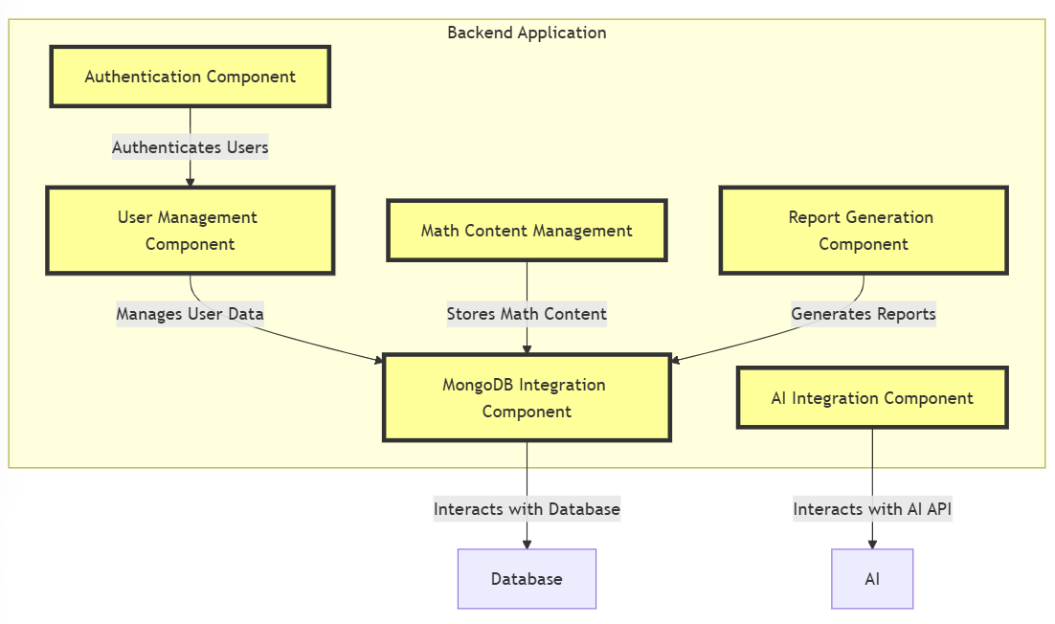

**THE CODE**

**graph** TD

**subgraph** "Backend Application"

        direction TB

        AuthComponent[Authentication Component]

        UserComponent[User Management Component]

        MathContentComponent[Math Content Management]

        AIComponent[AI Integration Component]

        ReportComponent[Report Generation Component]

        MongoDBIntegration[MongoDB Integration Component]

**end**

    AuthComponent **-->**|Authenticates Users| UserComponent

    UserComponent **-->**|Manages User Data| MongoDBIntegration

    MathContentComponent **-->**|Stores Math Content| MongoDBIntegration

    AIComponent **-->**|Interacts with AI API| AI

    ReportComponent **-->**|Generates Reports| MongoDBIntegration

    MongoDBIntegration **-->**|Interacts with Database| Database

    classDef component fill:#ff9,stroke:#333,stroke-width:4px**;**

    class AuthComponent,UserComponent,MathContentComponent,AIComponent,ReportComponent,MongoDBIntegration component**;**

**CODE DIAGRAM (C4)**

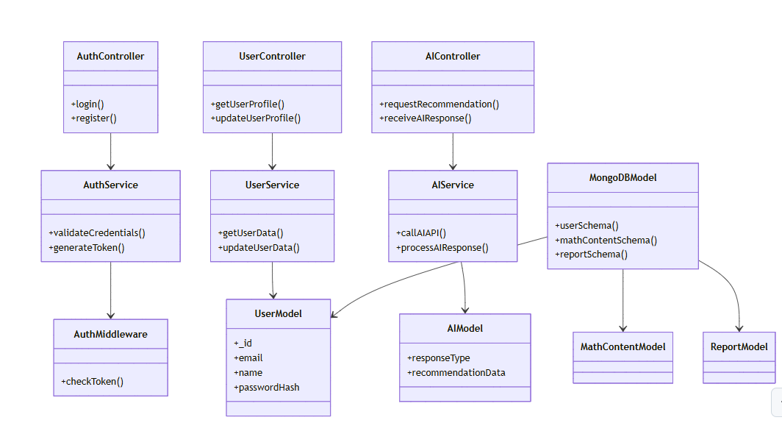

**THE CODE**

**classDiagram**

**class** AuthController **{**

**+**login**()**

**+**register**()**

**}**

**class** AuthService **{**

**+**validateCredentials**()**

**+**generateToken**()**

**}**

**class** AuthMiddleware **{**

**+**checkToken**()**

**}**

**class** UserController **{**

**+**getUserProfile**()**

**+**updateUserProfile**()**

**}**

**class** UserService **{**

**+**getUserData**()**

**+**updateUserData**()**

**}**

**class** UserModel **{**

**+**_id

**+**email

**+**name

**+**passwordHash

**}**

**class** AIController **{**

**+**requestRecommendation**()**

**+**receiveAIResponse**()**

**}**

**class** AIService **{**

**+**callAIAPI**()**

**+**processAIResponse**()**

**}**

**class** AIModel **{**

**+**responseType

**+**recommendationData

**}**

**class** MongoDBModel **{**

**+**userSchema**()**

**+**mathContentSchema**()**

**+**reportSchema**()**

**}**

    AuthController **-->** AuthService

    AuthService **-->** AuthMiddleware

    UserController **-->** UserService

    UserService **-->** UserModel

    AIController **-->** AIService

    AIService **-->** AIModel

    MongoDBModel **-->** UserModel

    MongoDBModel **-->** MathContentModel

    MongoDBModel **-->** ReportModel